

41

Target: ___/41 or ____ % 👍 👎

40

Year 8 HASS- Geography

40

**Task 6: *In Class Multiple Choice and***

***Short Answer Response***

***Changing Nations (5% weighting)***

Name:____________________________ Teacher: ___________________

**Time: 5 minutes reading time and 40 minutes working time.**

**Section One: Multiple Choice**

Read each key term, or statement, and circle only one option from A-D with a pencil as your response. **(8 marks)**

1. What type of city is New York with its population of 12 million?

A metacity

The capital city of the USA

A megacity

An omega city

1. Urban Sprawl is best defined as…

The outward spread of a city and its suburbs as it continues to grow.

The relocation from a city area to a rural area.

The increase of population living in the cities.

The increase of population living in rural areas.

1. The relocation from the city to the coast is known as;

Seed Change

Tree Change

Coast Change

Sea Change

1. In the decade 2001-2011 Perth’s population grew by 25%. Most of this growth was due to the;

Farming boom

Mining boom

Growth in marine industries

Growth in retail industry

1. Which of the following is not a world city?

New York

London

Paris

Perth

1. People who are accepted into a country for a short amount of time for a set type of employment are known as;

Contract workers

Professionals

Undocumented workers

Settlers

1. The movement of people from one country to another is known as;

International migration

Internal Migration

Urbanisation

Urban growth

1. Which of the following is the **correct** definition of internal migration’?

|  |
| --- |
| Movement of people from a foreign country to Australia |
| Movement of people from a city in one country to a city in another country |
| Movement of people within one country |
| Movement of people from Australia to a foreign country |

**Section Two: Short Answer**

* + - 1. Define Urbanisation with the use of examples to support your definition. **(3 marks)**

____________________________________________________________________________________________________________________________________________________________________________________________________________________________________________________________________________________________________________________________________________________

* + - 1. **List** four impacts of urbanisation;

**(4 marks)**

* + - 1. In the table below outline three **Push** factors and three **Pull** factors why people move to urban areas.

**(12 marks)**

|  |  |
| --- | --- |
| **Push Factors** | **Pull Factors** |
|  |  |
|  |  |
|  |  |

**SOURCE 1:**

Australia: RESIDENTS IN 2006 BY COUNTRY OF BIRTH

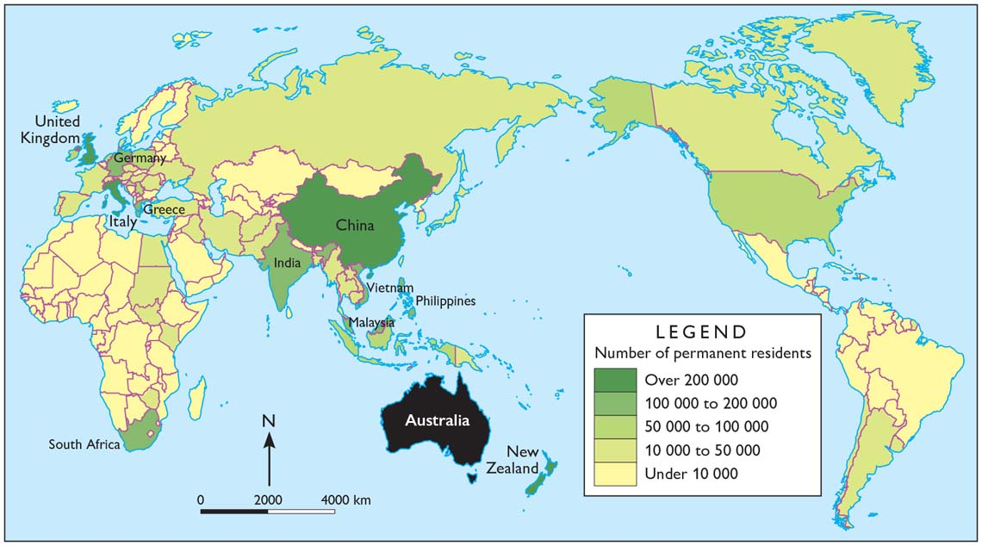

* + - 1. According to source 1 above which two countries contribute most to Australia’s overseas-born population? **(2 marks)**

* + - 1. In the table below define the terms “**Sea change”** and “**Tree change”** and provide an example of a location in **Western Australia** someone would move to experience one of these changes.

**(6 marks)**

|  |  |  |
| --- | --- | --- |
|  | **Sea Change** | **Tree Change** |
| **Definition:** |  |  |
| **Example in**  **Western Australia** |  |  |

1. Referring to Source 2 below **explain** three **push** and three **pull** factors that contribute to why people migrate to another country.

**(6 marks)**

**Source 2:**

[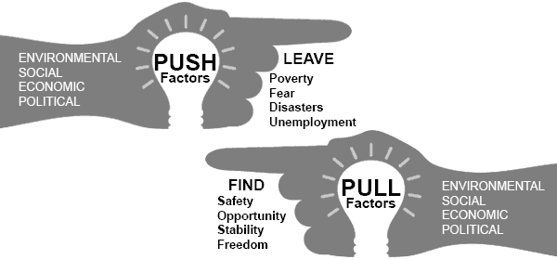](http://www.google.com.au/url?sa=i&rct=j&q=&esrc=s&source=images&cd=&cad=rja&uact=8&ved=0ahUKEwiTq-zni67WAhWBoJQKHWUvAFMQjRwIBw&url=http://www.emigration.link/&psig=AFQjCNELXLDeHNbWtWC4U8lk6ESw1_O9IQ&ust=1505802002754081)

**END OF ASSESSMENT**